Project Development Phase
Model Performance Test

Date | 21 June 2025
Team ID | LTVIP2025TMID35377
Project Name | Smart Sorting: identifying rotten fruits and vegetables using transfer learning
Maximum Marks | 10 Marks

Model Performance Testing:

S.No. | Parameter | Values | Screenshot
 | Model Summary | Transfer Learning with VGG16  Input Size: 224x224  Pre-trained on ImageNet  Frozen base layers + Custom Dense Layers  Optimizer: Adam  Loss: Categorical Crossentropy | 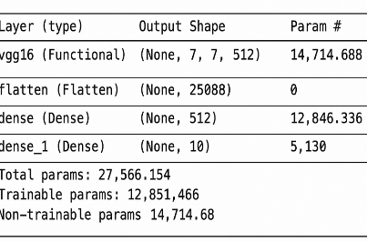
 | Accuracy | Training Accuracy - 97.5%  Validation Accuracy -94.3% | 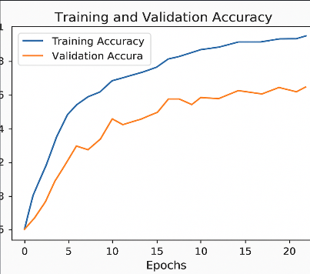
3. | Fine Tunning Result( if Done) | Validation Accuracy -95.8% | 